Cherryhurst Sidewalk Improvements Project Community Feedback

Below are all the questions received on or before December 2, 2024, from members of the public regarding the Cherryhurst Sidewalk Improvements public meeting on November 12, 2024. The responses provided are to the best knowledge of the design engineers and consultants at this point in time during the preliminary engineering phase of the project. This document will be made available at montrosehtx.org.

- Slippery ramps have led to injuries.
Response: Existing ramps will be replaced with new ADA compliant ramps

- Certain sidewalks flood.
Response: Sidewalks will be designed to reduce or eliminate flooding where possible.

- The Fairview/Windsor intersection should be replaced with a raised intersection.
Response: We have communicated to Houston Public Works about this. This intersection will be milled and overlaid as part of another project that will be done by Houston Public Works.

- Please improve the sidewalks near HISD bus stops.
Response: The project funding is restricted to providing better sidewalk connectivity to transit in the Cherryhurst area, so it will not be feasible to prioritize additional work near bus stops. We keep this location in mind and hopefully we be able to incorporate it in another project.

- The Mandell Street connection is much needed.
Response: The west sidewalk on Mandell Street will be replaced as part of this project.

- Ridgewood St corners are new. Why are we replacing?
Response: Any ramps that were recently constructed will be removed from the project scope.

- Why are there not sidewalk improvements on Ridgewood Street?
Response: There were recent sidewalk replacements on Ridgewood Street. Also, sidewalk improvements on Ridgewood Street are not possible between Missouri St and Cherryhurst St due to the locations of the trees. Users should take alternative routes to the bus stops on Westheimer Road.

- Why not extend the improvements further?
Response: TIRZ 27 received a METRO grant to replace existing deteriorated sidewalks in and around the Cherryhurst neighborhood and decided to fully leverage the $200k grant by contributing $800k for a total of $1M. This will extend sidewalk replacements by creating fully accessible routes throughout the entire project area while preserving mature trees. These improvements bring the cost to $1M.

- The good condition existing to remain sidewalk on the north side of Cherryhurst Street from Ridgewood to Windsor is higher than the rest. How will that be addressed?
Response: This will be investigated during the design phase.

- Consider a shared use path on Windsor Street.
Response: A shared use path will not be feasible along Windsor Street. There is not enough room within the right-of-way.

- Please consider extending the project boundary to connect Baker Elementary to Westheimer METRO stops.
Response: The project is limited to within the study area. Baker Elementary is outside the study area.

- The corner of Westheimer Road and Mandell Street is really bad.
Response: The sidewalk on the west side of Mandell is in good condition. On the east side, the sidewalk cannot be replaced due to the presence of mature trees with an extensive root system.

- The northwest corner of the park is a major slipping hazard.
Response: The ramp at the northwest corner will be replaced.

- My elderly aunt tripped on the west side of Windsor (between California St and Missouri St).
Response: The sidewalk on that side of the road is not being replaced due to the presence of mature trees with an extensive root system.

- I asked the company hired to redesign Cherryhurst Park's sidewalks if they had ever done this kind of work before. They said they had.

I asked if they felt good about the construction company with whom they had worked before. They said they had.

I asked if we could use this same construction company since they are proven to work well with the designer and do good work.

They said that we needed to go with the cheapest bid, if the company is deemed trustworthy.

I would like to suggest that we hire the company that has previously worked with our designer, since that combination has been tested already. If the construction company's bid is reasonable but not the lowest, we should avoid more costly future problems by hiring them.

Unfortunately, I learned this lesson the hard way when we remodeled our home on Cherryhurst St.
Response: By law, all public projects, like this one, have to be publicly advertised and bid. This gives all contractors an equal opportunity to bid on the project. This contractor can certainly submit once we advertise the project.

- I am the homeowner of 1805 Haver St in the Cherryhurst neighborhood.
According to the sidewalk project map it shows the sidewalk in front of my house being replaced.
I have a live oak that is pushing up on one section of the sidewalk today that creates a tripping hazard.
I am wondering if the replacement of the sidewalk will include preserving the tree roots (gravel over that area or a rise in the sidewalk) or if the plan is to cut the roots.
I would like to preserve as many trees in the area as possible similar to the way the sidewalks were redone on Ridgewood the other year when the redid the drainage.
Response: Sidewalks will be designed to preserve the tree roots. We have an urban forester working with us to ensure that the trees are fully protected. Also, there are two primary methods of doing this: (1) keeping sidewalks at 4 feet in width and (2) utilizing metal plates to span the roots. Gravel is not an option as it tends to wash out.

- Thank you for the informative meeting about the Cherryhurst sidewalk project. It’s an exciting initiative.

I didn’t get a chance to ask why none of the sidewalks in the park are included in the project. These are highly trafficked sidewalks and several are in poor condition. Will these be addressed separately by the parks department or is there another reason they were not included?
Response: The goal of the project due to the METRO grant is to bring pedestrians to bus stops. The sidewalks in the park do not contribute to this goal as sidewalks along the streets are more direct routes to the bus stops on Westheimer Road.

- Hello. I am the owner of 1818 Cherryhurst Street and my house is on the corner of Cherryhurst and Mandell. The existing material of the sidewalks in my grouping of townhomes, on both Cherryhurst and Mandell are a pea gravel mixture. My concern is that when the project starts, that it could be replaced with solid concrete. I am advocating and requesting to see if it is possible to have the existing material of pea gravel used to replace the areas on this particular section of the project.
Response: Yes, the design will specify a pea gravel mixture. However, it will likely look a bit different than the existing when complete.

- My name is John Griffin and I own the home at 1802 Cherryhurst St.

I have attached pictures of the 4 ramps at the intersection of Cherryhurst St. and Ridgewood St. All four of these ramps were updated as part of the drainage and resurfacing of Ridgewood that completed in 2021.

On your flyer, handed out at the Tuesday 11/12 meeting, these are marked as fair and in need of replacement.

I have also attached pictures of the ramps at the intersection of Haver St. and Ridgewood. These ramps were completed at the exact same time as part of the same project in 2021. As you might expect, they are all in exactly the same condition.

Hopefully, you won't actually be replacing the ramps at the intersection of Cherryhurst St. and Ridgewood since that would seem to be an unnecessary expenditure. I can say that my wife and I certainly DO NOT want the ramp replaced on the NW Corner in front of our home as there is no point.

Please let me know if you have any questions or would like any other information.
Response: Recently replaced ramps will not be reconstructed.

- My name is Frazier King and I live at the corner of Ridgewood and Missouri. I notice on your published plan for the project that you indicate that you have determined that the sidewalk ramps at this corner and the corner of Cherryhurst and Missouri are “Fair” and that they will be replaced. However, both of these ramps are only a couple of years old. I wonder If you could check on this because I do not believe that they need to be replace.
Response: Recently replaced ramps will not be reconstructed.

- Hi thank you for your recent visit to the cherryhurst civic association, Your team provided great details about the project and I am looking forward to the sidewalk improvements. I had a few questions

1. I followed up directly with David Greaney with Gauge Engineering but wanted to pass this along for your information as well. I provided David with pictures of our sidewalk after any rain storm. Our sidewalk at 1805 Fairview becomes a pond that collects and holds water for days in the sidewalk (which is the low spot) between 1803 and 1807 Fairview. This condition unfortunately requires students walking to school or any other pedestrians to cross Fairview or even worse walk out in the street to get by the inundated/muddy area until the area dries up over the following week or so. I asked David to consider this in his design so that we don’t perpetuate an issue and the new sidewalk is un-usable in wet conditions. I think if the sidewalk is elevated a bit (4-6 inches) and sloped to allow free draining to the storm drains located on Ridgewood and/or Mandell it would work out just fine.
Response: Gauge Engineering met with the homeowner on-site and identified potential solutions to improve the situation.

A few other comments or questions I would like you to consider.

Why aren’t the Sidewalks surrounding Baker Montessori in consideration for improvements while you have a contractor deployed in this area given its all within the TIRZ 27 area?
Response: That is beyond the study limits of this project. It will not be feasible to do that within this project. However, we will keep that in mind for future projects.

Will you reconsider the intersection reconstruction where Fairview crosses at Windsor? There are a lot of people that use this crossing for school access and or the neighborhood that go to Baker in the afternoon to use the track and park areas. Also if you do reconsider, I hope you have a design that would force drivers to slow down in these areas and make the crossing highly visible would be a huge improvement to what is there today.
Response: The City of Houston has an asphalt mill and overlay project that includes this intersection.

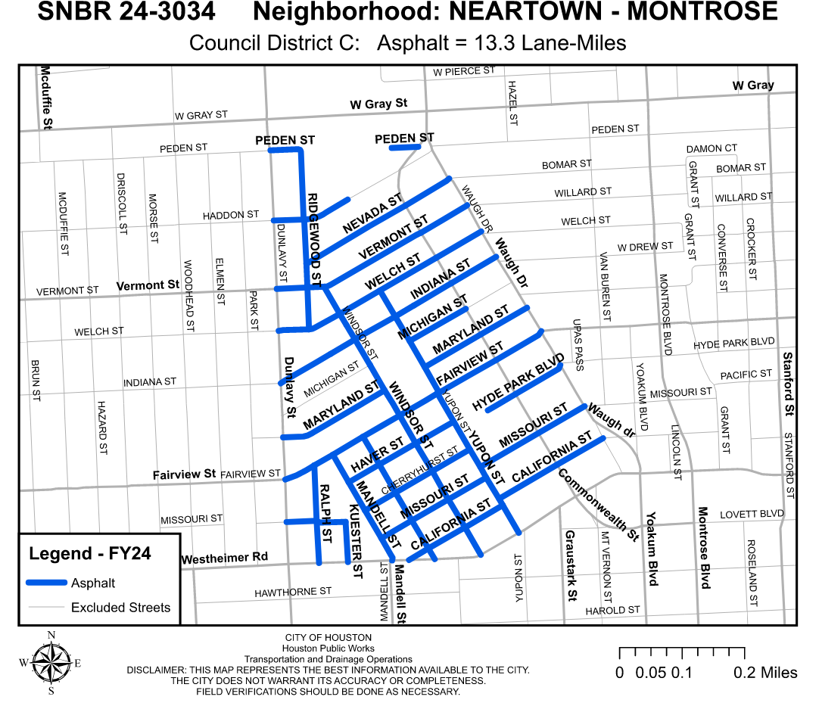
Again I appreciate the work you are doing and look forward to getting this project started. Thank you for any information you can provide and I appreciate your consideration of my questions. comments above.

- My name is Tony West. My home is located at 1621 Cherryhurst. I see from the plan that the sidewalk along my side yard on Windsor is planned to be replaced. I am concerned because these heritage oaks roots have buckled the sidewalk severely. Yet they make up most of the root ball because the roots are constricted between the sidewalk and the curb and street. So cutting them to replace the sidewalk would eliminate most of the roots drainage area. What can be done to make sure this does not harm these trees? I am anxious to know more about the plan.
Response: Sidewalks will be designed to preserve the tree roots. We have an urban forester working with us to ensure that the trees are fully protected. Also, there are two primary methods of doing this: (1) keeping sidewalks at 4 feet in width and (2) utilizing metal plates to span the roots. An individualized tree protection plan will be designed by an urban forester.

- Thank you for engaging with our community!

I'm the "Interim" Cherryhurst Civic Association President and live at 2506 Mandell Street.

My biggest concern is the Live Oak in front of my Townhome. The sidewalk is buckled and is in Gauge Engineering's plan to be replaced.

Question 1: Can a natural sidewalk be put in where you have a slight and gradual incline and decline using gravel? I don't want to hurt the tree; truth be told, the tree was the main reason I bought the Townhome in 2011. It is likely 100 years old.
Response: Natural sidewalks are not being considered as part of the design. Sidewalks will be designed to preserve the tree roots. We have an urban forester working with us to ensure that the trees are fully protected. Also, there are two primary methods of doing this: (1) keeping sidewalks at 4 feet in width and (2) utilizing metal plates to span the roots. An individualized tree protection plan will be designed by an urban forester.

Question 2: Last year, we had people marketing the natural gas lines, and I asked the workers, and they said there was a plan to replace the water lines. If you put in new sidewalks on Mandell next year, and then in two years, they put in new water lines that connect to our water meters, will the sidewalks have to be ripped up?
Response: Gauge Engineering will coordinate with all overlapping projects to minimize repeated work if at all possible.

Your thoughts are appreciated!

